Make Mine Mystery

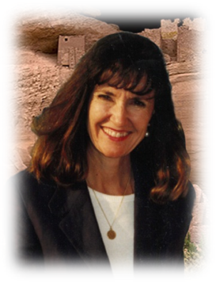

Krista Lynn

December 5, 2018

L Lee Kane

I’d like to interview friend, fellow author, and artist as my guest this month, Krista Lynn. I want to share her new book, The Nora Pigeon Mysteries with quirky characters that are reminiscent of Agatha Christie novels. The three short stories have strong appeal, interesting plot lines, beautiful scenes, and colorful dialog. If you’re looking for a cozy read this winter, in front of a fireplace, glass of wine in hand, this is the book for you.

**Tell us about The Nora Pigeon Mysteries:**

From helping her best friend sort out a deadly family drama, to exonerating a woman charged with killing her husband with a dousing switch, to solving the theft of precious ancient runes, Nora Pigeon never fails to find the truth. Using her “ancient forms of inquiry,” and a crew of human and canine friends, Nora stays one step ahead of law enforcement and forever in the way of her beloved and often exasperated nephew - Sheriff’s Detective, Thomas J. Pigeon.

**Who did you write your book for?**

The original story, Blue Moon Blues was written to enter a mystery contest. It won for best new author, I’m happy to say. So, the intended audience from the start were people who like whodunits. As the character and stories continued to come to me, I knew they were perfect for the Cozy Mystery genre. If one likes Agatha Christies’ Miss Marple, and enjoys humor and dogs and clever plots, then Nora Pigeon is a good bet for an engaging read.

**Is there a central message in your book?**

Friendship. Believing in the good of people and sometimes looking beyond the surface to find that goodness. And for fun, Nora uses what her detective nephew, Thomas, calls those “ancient forms of inquiry.”

**If you had to choose, what would you say is the single most important idea you're sharing in your book that is  
really going to add value to a reader’s life?**

This series showcases characters in several occupations that are interesting. One story, *Blue Moon Blues*, highlights an author who writes urban fantasy and almost falls prey to relatives who want to take advantage of her success in publishing. The next story, *The Doused Witch*, revolves around ‘Water Witching,’ which is the practice of finding water with a forked branch from a tree. That story relates how water ownership is often the source of conflict that can cause violence. And the last tale, *The Rune of Her*, is about the importance of ancient artifacts being kept in the country where they are found.

Each story is a ‘Cozy’ with quirky characters, and rascally dogs!   
 **If you could compare this book with any book we might already be familiar with, which book would it  
be and why?**

There aren’t too many characters like Nora Pigeon! But I like the “A Tourist Trap” novellas series by Lynn Cahoon. *A Deadly Brew* is a good story in that series.

**Tell us about the central characters in the book?**

Nora Pigeon is my version of the mature mystery-solver—a well-known psychic and healer who uses various ‘mediums’ to ferret out the truth when a crime is committed. Nora, and her partner, Francine Bayley, co-own Pigeon and Bayley’s Arcane Treasures Shoppe where one can purchase items of magic and the occult. While Nora is famous as a psychic and healer with an aura of calm composure, Francine, just shy of four feet in height, with wild curly hair and scattered focus, is known for her knowledge of ancient runes and Nordic culture. Together, Nora and “Frannie” re-opened the shop and imbue it with the spell of friendship and magic.

Nora’s best friend and cohort in many of her ‘cases’ is the famous urban fantasy author, Cassandra Cartwright, who is always up for one of Nora’s ‘investigative’ jaunts. And to round out Nora’s human cohorts, we have Nora’s oft-frustrated nephew, Thomas Pigeon, who is a Sheriff’s detective. He loves his aunt dearly, but wishes she would just let him solve a case by himself.

Then, there are the dogs – two Great Danes, Odin and Thor, and one mischievous Yorkie who lives to leave his mark on the shoes of selected victims. His nickname is Kipper the Pee-Shooter. In each case, Nora’s canine assistants are integral in crime solving.

**Tell us your most rewarding experience since publishing your work?**

Two great experiences come to mind right away. 1, receiving good reviews from my efforts! It is so rewarding when someone leaves a good comment, or tells you in person that they liked your book. And 2, getting to know other writers, enjoying their friendship and working together to make the most out of our writing endeavors.

**If someone wrote a book about your life, what would the title be?**

Krista Lynn: One very lucky person

**How would you describe your writing style?**

I’m not sure how one answers this question. I write how I do, and the ‘style’ is just how I write, LOL. Some say I write ‘lyrically,’ which I take to mean - with a poetic bent in description. I do think that is true of my *Haunted Canyon* series. To put the reader into the world of the Sonoran Desert where the story takes place, I would be remiss if I didn’t describe the desert as something wildly beautiful. ☺

In the Nora series, I dive right into dialog and character development. I adore the characters and it is really true, as other authors have told me that characters write themselves – they are the muses that keep the author’s fingers on the keyboard. I’m so looking forward to writing a Nora novella. I’m sure she and Thomas will enjoy telling me what to write!

**Who influenced your writing the most?**

M.M. Kaye, Tony Hillerman, Bronte sisters, Daphne Du Maurier, Michael Connelly, Dennis Lehane – all authors that I admire. Linda Howard’s *Death Angel* inspired to write my first story based on a character in that book. *Death Angel* and *Cry No More* by Linda Howard influenced me a lot.

**Are your characters pure fiction, or did you draw from people you know?**

The characters in the Canyon Series were inspired by people I knew in my youth. Those in Nora Pigeon series are probably fashioned after many people I’ve known over time. That’s the way it is for a writer, I think. Every character, setting, and circumstance is borrowed to some degree from real-life experiences.

**Are you more of a character artist or a plot-driven writer?**

I don’t think you can have one without the other. I write for the characters, but if they don’t have a reason, a challenge, a mystery to be going on with – then why do they exist? So, I try to make my stories have interesting characters in the middle of interesting plots.

For instance, The Nora Pigeon Mysteries. The characters resonate with readers, but reviews of the stories always mention the mystery, the plot, as well. In each of the short stories in this anthology, the plot involves psychic elements. Nora uses her ancient Ouija Board or Tarot Cards, or Runes.

At the start of the series, I knew very little about Tarot Cards or runes and did quite a bit of research so I could show Nora’s expertise. As a child, we used the Ouija Board to try and find the gold purportedly hidden in the hills of Arizona after a 1902 stagecoach robbery (true story!) Of course, we found no gold, but had a lot of fun with the Ouija. By the way, did you know that Ouija is a combination of the word yes? French *‘oui’*, and German *‘ja’*?

For research, I dusted off a deck of Tarot cards that I bought in Paris years ago and started to study them. Now, at least once a week, I do a quick study of one or two of the cards. Did you know that our standard deck of playing cards is related to the Tarot?

The runes are probably the most interesting to me because in addition to their relationship to nature and human emotions, they also relate to letters in our alphabet. For over a thousand years, runes have been used to tell the future, to see the truth of a situation, and to leave written ‘inscriptions’ on their homes, gravestones and other surfaces such as bone and wood.

It’s been so much fun researching and using these three implements in Nora’s stories. They are all intricate parts of each plot.

**Who should buy this book?**

Lovers of cozy mysteries will enjoy Nora Pigeon. Those who love Miss Marple and Poirot will ‘get’ these humorous mysteries.

**Where can readers find you and your book?**

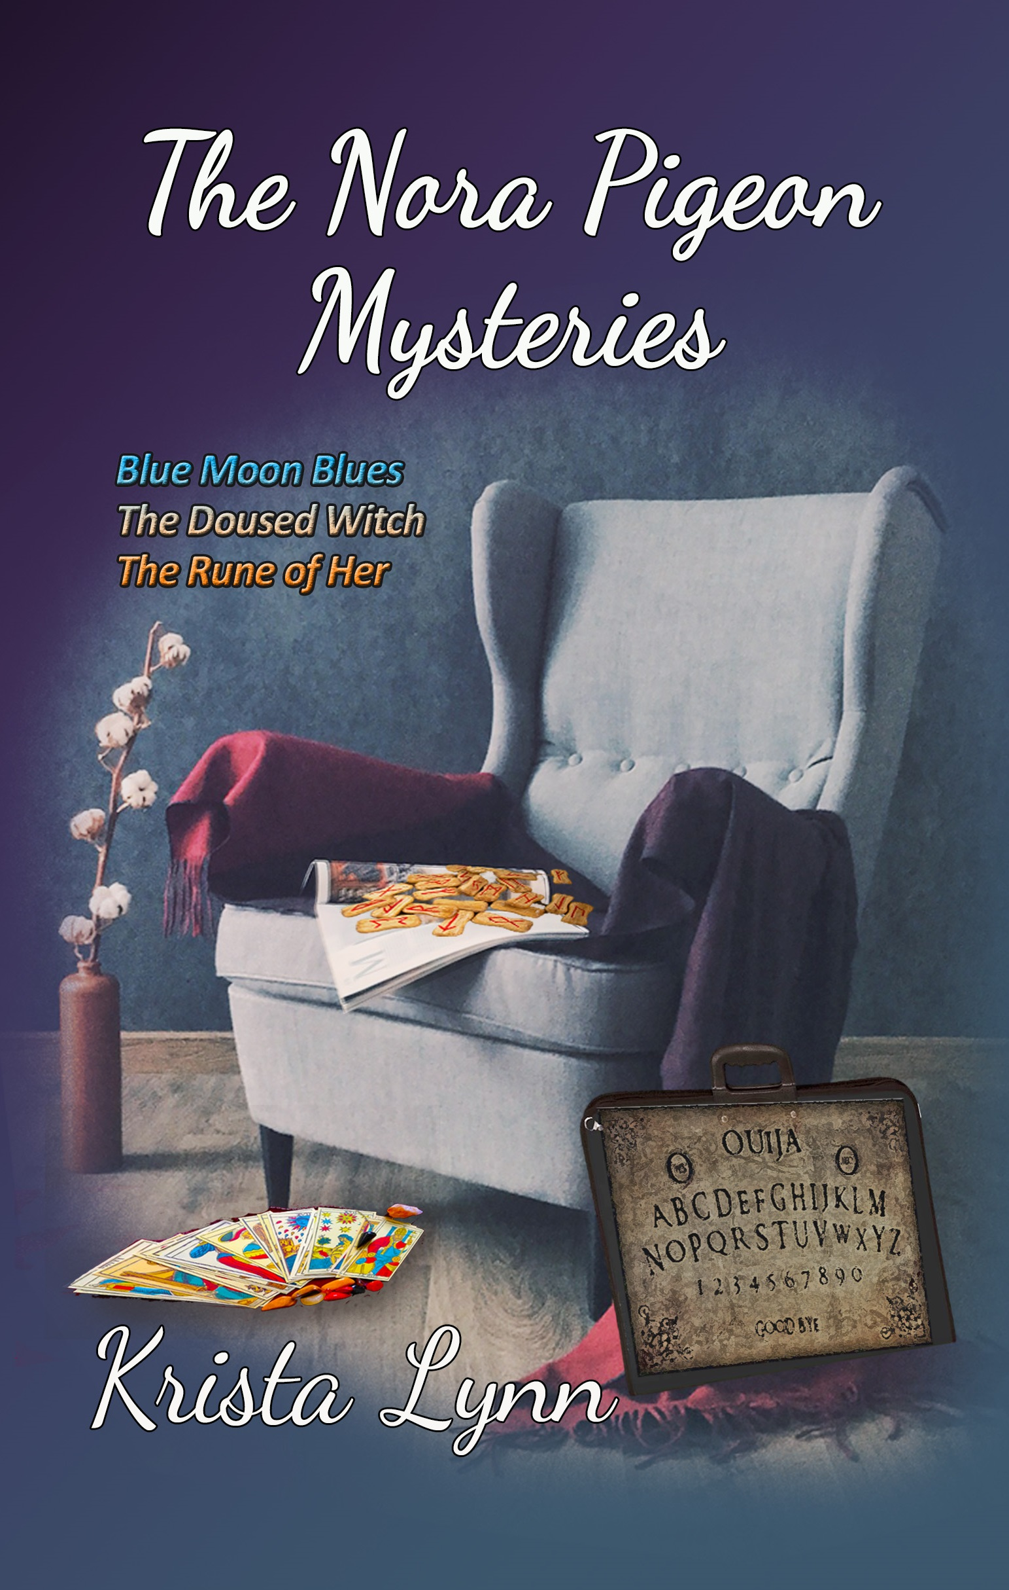

***Amazon!***

**Nora Pigeon uses her psychic gifts to help law enforcement.**

**Whether they want it or not!** <http://bit.ly/norapigeon>

And check out the first book in the Sunset Canyon Series

**One woman scientist + One mysterious deputy sheriff + One haunted canyon =   
 More puzzling clues than science can unravel.**

[http://amzn.to/2rdujrW](https://t.co/2YgHNweNvM)

